Veracity CDR User Guide
This is a quick tutorial on how to use the Veracity CDR call details reporting system.
Topics:
- Where To Login
- Reporting Options
  - Setting Date Ranges
  - Exporting To CSV Or PDF Files
  - Scheduling Reports
- Settings Options
- Appendix: Seven Popular Sample Reports

- Where To Login

You login to our call data reporting system at https://reports.veracitynetworks.com. There is a “lost password” link if you’ve forgotten your password. But that is dependent on your having your email address registered to our system. If not then you can email us at csgroup@veracitynetworks.com or you can call us at 801-437-6566 for assistance with your login.

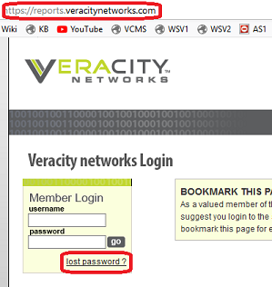

- Reporting Options

You will default to the reports section when you login. But you can always navigate back to that area by clicking the Reports option at the top of our page. From there, we have a wide variety of reports available where you can view incoming, outgoing and both ways of calls.

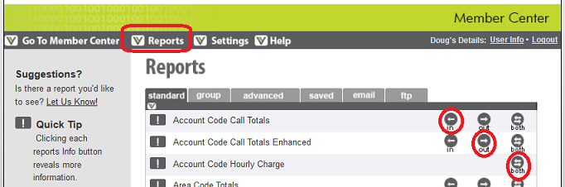

By default, you will pull up 500 results per page. This can be set to a different number in the Preferences section of the Settings area. You can also click All to view all of your call data in a single web page.

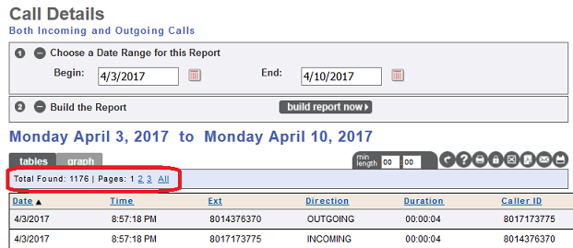
- Setting Date Ranges

Clicking the In, Out or Both icons will generate a report for the last 7 days by default. But once you’ve pulled up a default report, you can reset the date range. We tentatively plan to keep this data for at least 13 months but that time frame might be extended.

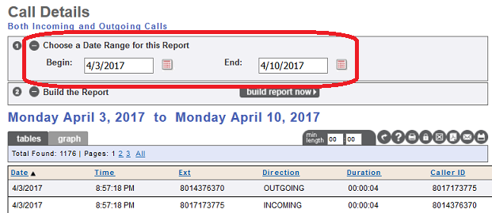

- Exporting To CSV Or PDF Files

Hovering over these icons will cause a text pop-up that tells you what they do. You can print, save, email and schedule reports with these icons. The icons for exporting the results to a CSV (Excel) or PDF file are highlighted below.

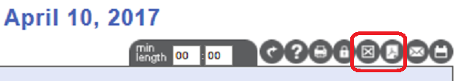

- Scheduling Reports

The last icon is for scheduling ongoing reports. You can schedule daily, weekly & monthly reports and you can specify which registered email addresses will receive the report. Thus, multiple supervisors & managers can receive them in HTML, PDF or CSV format. There is a link to add more email addresses as needed.

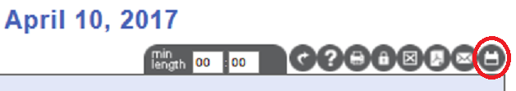
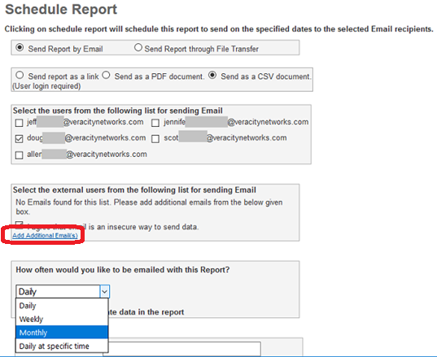

- Settings Options

The Settings section gives you several options for labeling your accounts, extensions and phone numbers so that you can easily associate individuals with the numbers in your reports. The Report Viewing Preferences link will let you reset the number of records that show per web page.

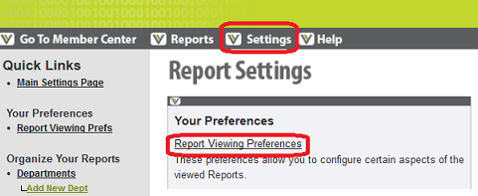

Here are the main settings available.

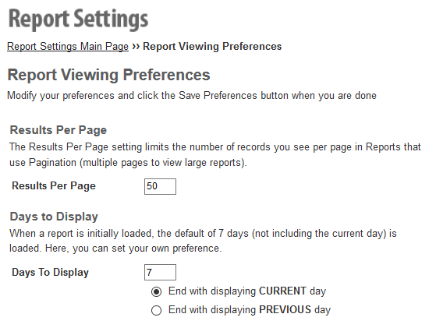

- Appendix – Seven Popular Sample Reports

The rest of this document will show samples of seven of our most popular reports. We’ll be showing the HTML view of the reports but keep in mind that you can export the data to CSV (spreadsheet) and PDF files.

- Extension Hourly Call Totals (spreadsheet view)
- Call Details Report
- Day Of The Week Totals
- By Extension: Call Details
- By Extension: Average Call Duration
- Hourly Call Details
- Longest Phone Calls

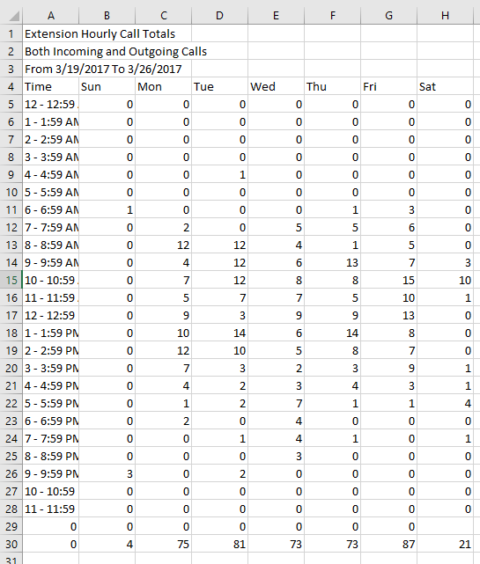
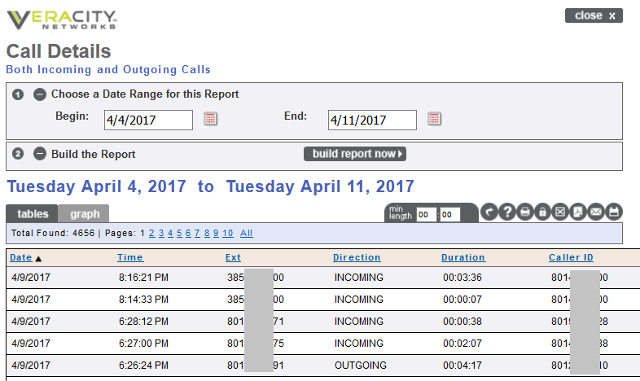

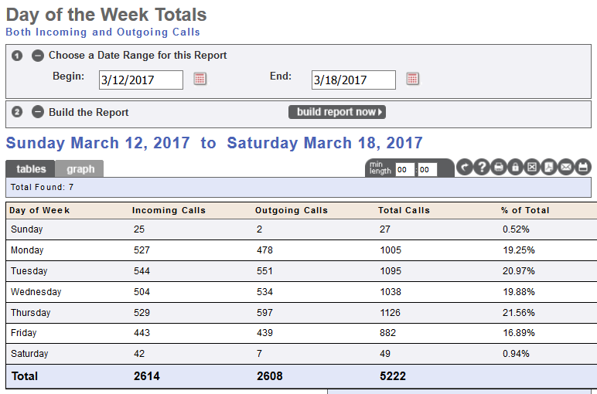

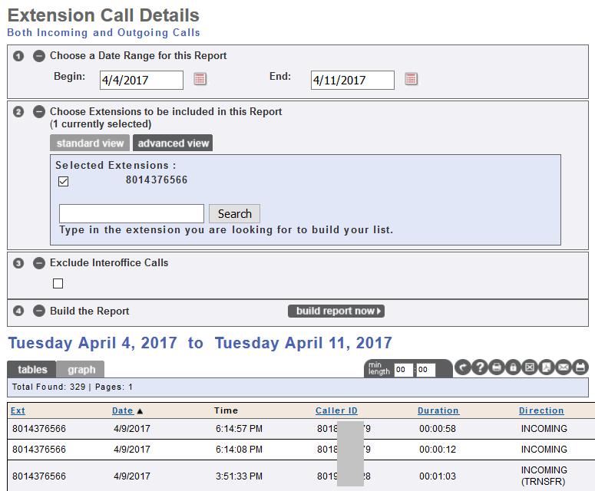

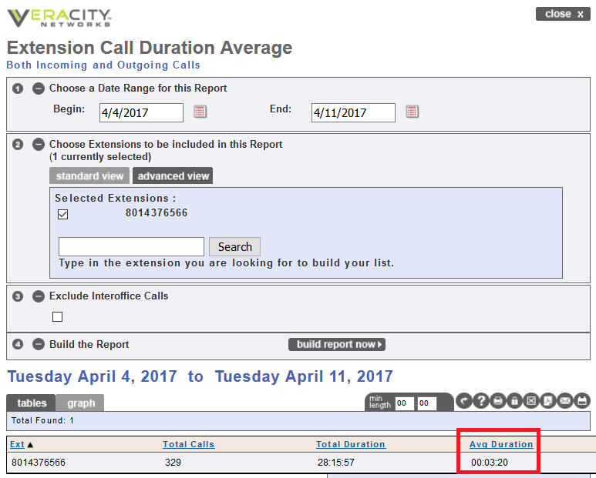

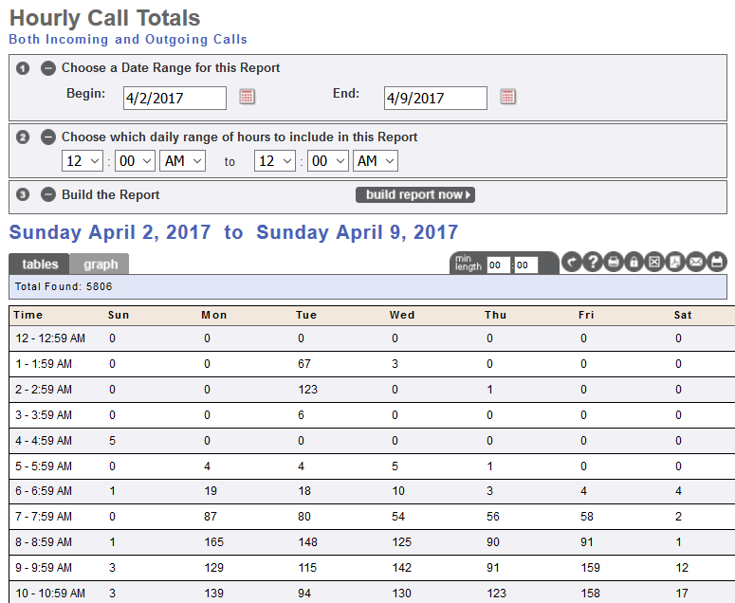

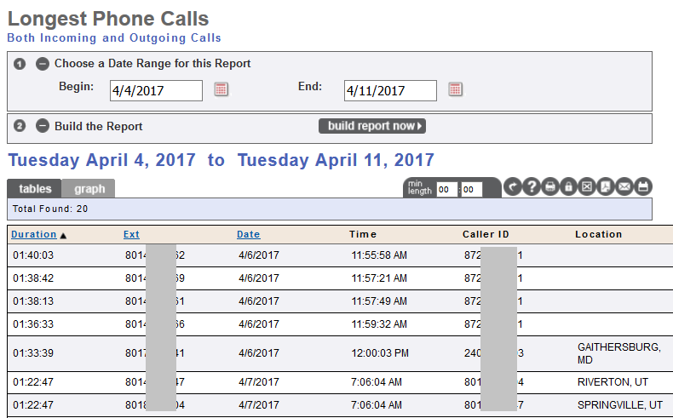

<end of document>

