How To Ping And Trace Route With A Polycom Phone
Sometimes it is helpful to ping & trace route to see if a Polycom phone is reaching their local EdgeWater or possibly the Sansay cloud. This page shows you how to do that. Begin by clicking the House button to get to this screen. Now click the Settings button.
These screen shots are from a VVX 400 but the steps are numbered and named the same on most if not all Polycom phones.
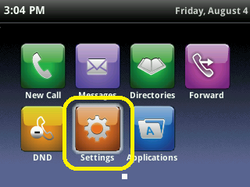

Choose option 4 Status. You can navigate down to it and use the Select button but it's much easier and faster to simply dial the number 4 on the phone.
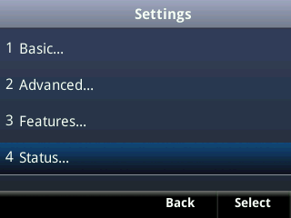

Let's stick with number 4 to go into the Diagnostics section.
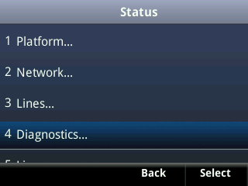

Let's do 4 again. It has been working so far. That is the Network option.
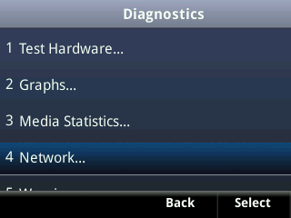

And here we are. Choose 1 to Ping or 2 to Trace Route.
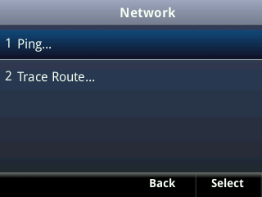

This is the Trace Route screen. Put in the IP address in the Host box at the top. You use the * asterisk * on the phone's keypad to put in the periods.
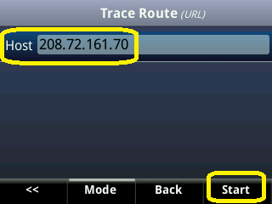

Scroll down looking for breakage and errors.
