How To Logout An Agent From CC-One

This page will show you how a CC-One v10+ administrator can log out an agent who forgot to log out. Begin by opening the Real-Time Reports. It's in the left sidebar of https://portal.ccone.net. You might need to scroll down a bit. | 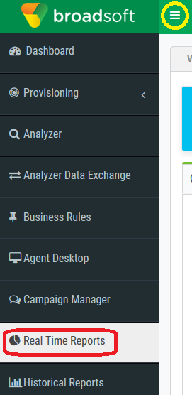

Click the dropdown arrow next to Agent Reports at the top and choose the View Snapshot Reports option. | 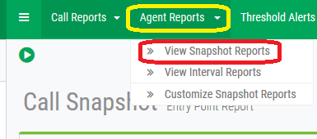

Your queues will pop-up below that. Click the team that has the agent that you want to logout. | 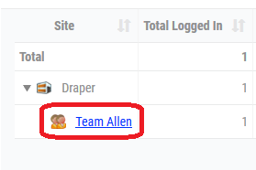

Click the log out icon. Confirm and you're done. | 