# Levels of Administration in the World of Cisco Webex Contact Center

* **Active Directory** is foundational to your company’s business.
  + Corporate administrator-rights needed to add accounts
  + It provides the structure for Single Sign-on
* **Control Hub** is like AD for Cisco Webex products/services such as Webex Contact Center, Webex Teams, Webex Meetings, Webex Calling, etc.
  + It associates domain(s) to an organization in the Control Hub.
  + Admin (internal or external) accounts are used to provision a WCC tenant
  + Users are managed here including which of the Webex products each user can use
* **Webex Contact Center** synchronizes with Control Hub to get Users names and emails.
  + The licensing (Standard or Premium) is assigned in WCC.
  + Managing agents roles are assigned in WCC

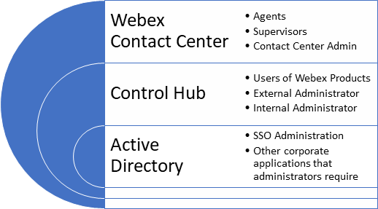  
These entities are layer on top of one another. You need AD and Control Hub to have a WCC.

Different administrative rights are needed to manage each level.