[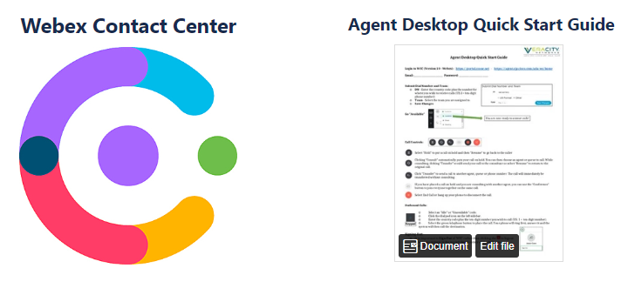](https://veracitykb.atlassian.net/wiki/spaces/KB/pages/12812312/WCC+Agent+Training)

To start your journey as a System Administrator of a Cisco Webex Contact Center you may want to familiarize yourself with terms and concepts. This short video, less than 4 minutes long, is a great place to begin:

[](https://veracitykb.atlassian.net/wiki/spaces/KB/pages/351830214/Introduction+to+Terms)

On the Veracity Networks Knowledgebase, we have longer, more in-depth videos that we invite you to view. Notice that some videos and documents are for the Administrator and the Management Portal and others are for the Agent and the Agent Desktop client.

The suggested approach for the different users:

|  |  |
| --- | --- |
| **Audience** | **Training Videos** |
| Agent | | **Topic** | **Length** | | --- | --- | | [Full Agent Desktop Video](https://veracitykb.atlassian.net/wiki/download/attachments/12812312/WCC%20Agent%20Desktop%20Training%20-%20Full%20Video.mp4?version=1&modificationDate=1582215032908&cacheVersion=1&api=v2) | Total 16:37 |  |  |  | | --- | --- | | [Logging in](https://veracitykb.atlassian.net/wiki/download/attachments/12812312/WCC%20Agent%20Desktop%20Training%20-%20Logging%20In.mp4?version=3&modificationDate=1582155400650&cacheVersion=1&api=v2) | 2:57 | | [Answering Calls](https://veracitykb.atlassian.net/wiki/download/attachments/12812312/WCC%20Agent%20Desktop%20Training%20-%20Answering%20Calls.mp4?version=1&modificationDate=1582155767569&cacheVersion=1&api=v2) | 2:14 | | [Call Controls](https://veracitykb.atlassian.net/wiki/download/attachments/12812312/WCC%20Agent%20Desktop%20Training%20-%20Call%20Controls.mp4?version=1&modificationDate=1582156341597&cacheVersion=1&api=v2) | 2:34 | | [Wrapping Up Calls](https://veracitykb.atlassian.net/wiki/download/attachments/12812312/WCC%20Agent%20Desktop%20Training%20-%20Wrapping%20Up%20Calls.mp4?version=1&modificationDate=1582209693159&cacheVersion=1&api=v2) | 1:01 | | [Outbound Calls](https://veracitykb.atlassian.net/wiki/download/attachments/12812312/WCC%20Agent%20Desktop%20Training%20-%20Outbound%20Calls.mp4?version=1&modificationDate=1582157749817&cacheVersion=1&api=v2) | 4:20 | | [Additional Information](https://veracitykb.atlassian.net/wiki/download/attachments/12812312/WCC%20Agent%20Desktop%20Training%20-%20Additional%20Information.mp4?version=1&modificationDate=1582210581007&cacheVersion=1&api=v2) | 3:11 |  |  |  | | --- | --- | |  |  | |

|  |  |  |  |  |  |  |  |  |  |  |  |  |  |  |  |  |  |  |  |  |  |  |  |  |  |
| --- | --- | --- | --- | --- | --- | --- | --- | --- | --- | --- | --- | --- | --- | --- | --- | --- | --- | --- | --- | --- | --- | --- | --- | --- | --- |
| Supervisor | |  |  | | --- | --- | | **Topic** | **Time Stamp in Video** | | [WCC Call Recordings](https://veracitykb.atlassian.net/wiki/spaces/KB/pages/351830141/WCC+Call+Recordings) | Total 4:05 |  |  |  | | --- | --- | | Call Recording | 0:00 | | Recording Management | 2:30 |  |  |  | | --- | --- | |  |  | | **Topic** | **Time Stamp in Video** | | [WCC Call Monitoring](https://veracitykb.atlassian.net/wiki/spaces/KB/pages/351830165/WCC+Call+Monitoring) | 6:16 |  |  |  | | --- | --- | | Call Monitoring Overview | 0:00 | | Call Monitoring & Recording | 1:55 | | Call Monitoring Types | 2:10 | | Setting Up Monitoring Queues | 2:40 | | Creating Call Monitoring Schedules | 4.10 | |
| Administrator | |  |  | | --- | --- | | **Topic** | **Time Stamp in Video** | | [WCC Admin Dashboard](https://veracitykb.atlassian.net/wiki/spaces/KB/pages/351830065/WCC+Admin+Dashboard) | Total 4:51 |  |  |  | | --- | --- | | Launching the Dashboard | 0:00 | | Introduction for logging in | 0:25 | | Admin vs. Agent Views | 0:50 | | Admin Dashboard | 1:55 | | Overview and functions of Dashboard | 2:30 | | Other Modules Overview | 3:35 |  |  |  | | --- | --- | |  |  | | [WCC Entry Points & Queues](https://veracitykb.atlassian.net/wiki/spaces/KB/pages/351830088/WCC+Entry+Points+Queues) | Total 7:32 |  |  |  | | --- | --- | | Typical Call | 0:00 | | Introducing Entry Points | 0:29 | | Creating Entry Points | 1:53 | | Queue Settings | 3:57 |  |  |  | | --- | --- | |  |  | | [WCC Provisioning Essentials](https://veracitykb.atlassian.net/wiki/spaces/KB/pages/351830079/WCC+Provisioning+Essentials) | Total 13:57 |  |  |  | | --- | --- | | Overview | 0:00 | | Teams | 3:15 | | Agents | 6:26 | | Address Book | 11:40 | | Auxiliary Codes | 13:11 | |  |  | | [WCC Routing Strategies](https://veracitykb.atlassian.net/wiki/spaces/KB/pages/351731780/WCC+Routing+Strategies) | Total 51:37 | | Entry Points & Queues | 0:00 | | Routing Strategies (part 1) | 1:30 | | Control Scripts | 3:11 | | Entry Point Example | 5:36 | | Routing Strategies (part 2) | 10:26 | | Current Routing Strategies | 16:11 | | Global Routing Strategies | 21:39 | | Routing Strategies Example | 23:41 | | Routing Strategies Example - EP | 26:07 | | Routing Strategies Example - Queues | 27:07 | | Call Flow Builder - Control Scripts Library | 34:19 | | Routing Strategies Walk-Through | 38:10 | |

[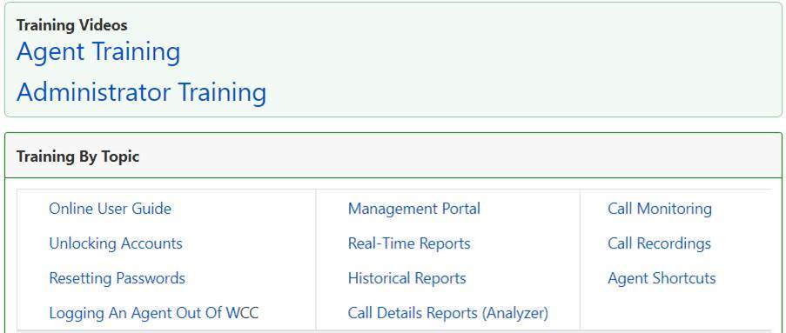](https://veracitykb.atlassian.net/wiki/spaces/KB/pages/12812308/Webex+Contact+Center)

[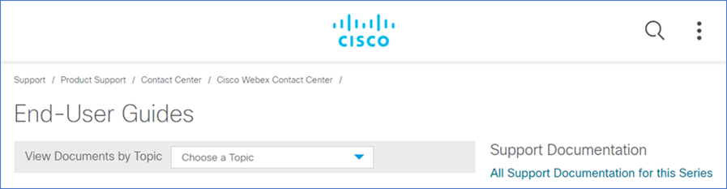](https://www.cisco.com/c/en/us/support/customer-collaboration/customer-journey-platform/products-user-guide-list.html)



On the Veracity Networks Knowledgebase we have other extremely helpful documents that we would like to invite you to view.   
For example, we have Quick Start Guides for Agents, Supervisors, and Administrators.

[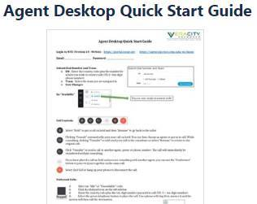](https://veracitykb.atlassian.net/wiki/spaces/KB/pages/12812312/WCC+Agent+Training?preview=/12812312/448069750/WCC%20Agent%20Desktop%20Quick%20Start%20Guide%20New%20Version.docx) A screenshot of a cell phone

[](https://veracitykb.atlassian.net/wiki/spaces/KB/pages/495419397/WCC+Administrator+Quick+Start+Guide)

](https://veracitykb.atlassian.net/wiki/spaces/KB/pages/495419397/WCC+Administrator+Quick+Start+Guide)