Polycom VVX400 Phone User Manual
Let’s take a tour of the Polycom VVX400/410 phone. We’re going to cover the following topics:

Screen Views & Call Handling
Buttons, Line Keys & Soft Keys
Contact Directories, Call Logs & Speed Dials
Settings Including Ring Tone Options
DND Do Not Disturb & Call Forwarding

Screen Views & Call Handling
Quick Links: Making Calls – Call Holds – Conference Calls – Blind Transfers – Warm Transfers – Shared Call Appearances – Busy Lamp Fields
There are 3 types of views on a VVX400/410. They have a Home View, Lines View & Call View. You use the house button to navigate between them.

Home View

We’ll start with the Home View shown here. The options are pretty self-explanatory except that the call history is buried in the Directories section. Most of the buttons on the home view have their own section so let's move on to the call view. There are links to these sections just below here. | 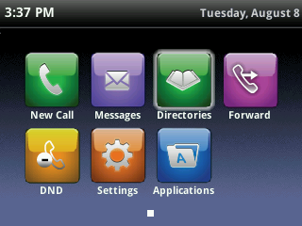

Quick Links: Messages – Directories – DND Do Not Disturb – Call Forwarding – Settings

Call View & Call Handling

The call view looks like this screen shot when you receive a call. You can press the Answer soft key at the bottom but it's easier to just pickup the handset. You can also use the speaker phone button or the headset button if you are setup with a headset for your calls. | 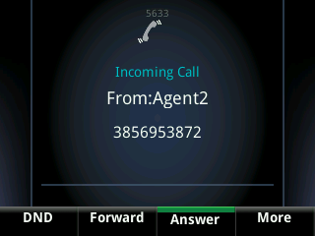

If you have multiple lines then you can tell which extension is receiving the call because the line key to the left of that extension will light up green. Just press on that button to answer the call. It will default to speaker phone unless you've already lifted the handset or activated the headset button. | 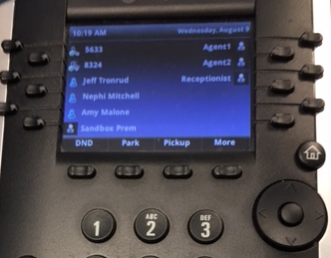

If one of these non-handset options is active then that button will be lit up green. If you press a lit button then the call will automatically go on hold and the green light will turn off. Press the button again to resume the call on the headset or speaker phone.

There are various ways that you can initiate a call. You could go to the home view and choose the New Call option but that is the long route. It's much easier to simply start putting the number in the keypad. Press the Send soft key at the bottom after you've finished dialing.  The << soft key to the right of Send and Cancel is how you delete a typo. | 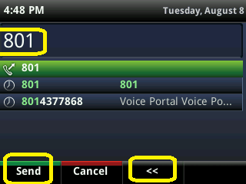

You can also use the speaker phone button on the right or the headset button if you're setup for that. The speaker phone button is the one in the middle this photo that looks like a speaker. Above that button is the headset button. If one of those options is active then the button will be lit up green.
Speed Dials are another option. They are covered in a later section.

This is how the Call View looks when there is a live phone call. This phone has 2 lines which are extensions 5633 & 8324. The first thing this highlighted box shows is which extension is on the call. It then shows the caller ID (which was Agent 2 in this screenshot) and it shows his phone number. Lastly, the call was 2 minutes and 23 seconds into the phone call. | 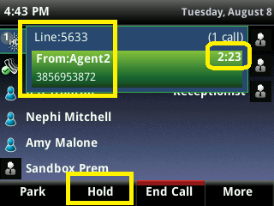

There are several ways that you can put this call on hold to do things like setup a conference call or make a transfer. There is a Hold soft key button at the bottom of the screen. You also have a hold button on the phone as highlighted in this screen shot. If you press More and choose to transfer then the call automatically goes on hold. And if you are on the speaker phone or a headset and you press that lit button on the phone then that won't end the call. That will put the call on hold. Press the Hold button again to take the call off hold. | 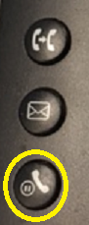

This is what it looks like if a call is on hold. You can take the call off hold by using the Resume soft key. You can also use the button described above as well as the speaker phone button or the headset button if applicable.  The soft key options at the bottom vary by license type and firmware version on the phone. In this example, we've got Park, Pull, Retrieve & More with more options if you choose that last one. | 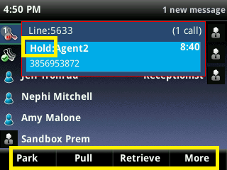

A Call Park is where you can park a call against any valid extension in your organization including possibly your own. Then you can go to a different phone or a co-worker can use the Retrieve option to grab that call on the other phone.
There are several ways to get two calls going at once. The main way is to put the first call on hold then use the New Call soft key to call the 2nd person. You can then initiate a transfer or conference call. The Join soft key also causes a 3-way conference call.

This is a screen shot where the phone has two calls going. Extension 5633 is talking to Agent 2 while extension 8324 has the Receptionist on hold. You don't need to have two different extensions though. Either extension could have two calls going on the same extension but one would need to be on hold unless you've setup a conference call via the Confrnc or Join soft key. | 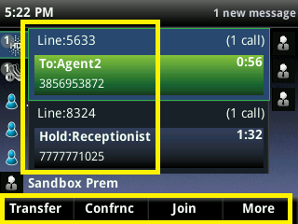

While on a call, if you use the Transfer soft key then you will get this screen. You can use a soft key to switch to the Lines view or you can "Blind Transfer" which gives you a 2nd screen to put in a number and then you would click the Send soft key. A blind transfer is where you don't talk to the destination before handing off the first caller. If you switch to Lines view then you can use a speed dial if you've got any speed dials setup on your phone. | 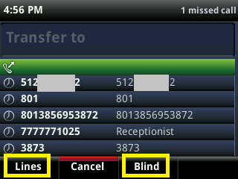
You have a default transfer type but you can selectively transfer calls with the non-default option by holding down for a few seconds on the Transfer soft key until the screen changes.
No matter which default transfer type you've got, the other type will be available as a soft key. You might have to use the More soft key to see it. This screenshot is doing a blind transfer but there is a consultative soft key to switch to the other transfer type. The previous screenshot was a warm transfer with a Blind soft key to switch for that one call. | 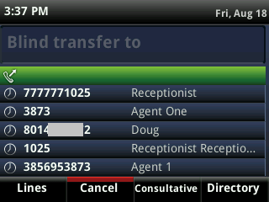
If you want to do a "Warm Transfer" a/k/a a consultative transfer then don't press the Blind soft key. Just start keying in a phone number or extension and the screen changes to this screenshot. Use the Send key when you've got your number ready. The << key can be used if you "fat finger" a keyed number. |  | 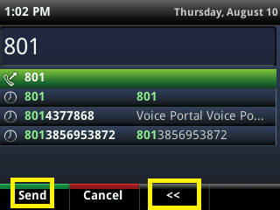

Talk to your destination then click the Transfer soft key again to transfer the original caller to the new destination. If they don't want the transfer then use the Cancel soft key then take the first call off hold. | 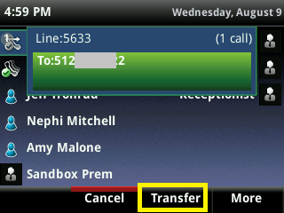

Lines View

This is the lines view. We'll break it into pieces starting with your main line and any other shared lines that you might have on your phone. | 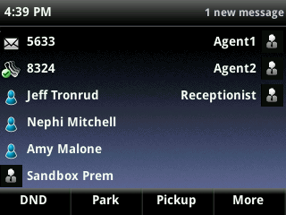

Let's start in the top left corner where the main line is situated. In this screenshot, that is extension 5633 while the green check mark telephone logo just below 5633 at extension 8324 is a shared line known in the telephony industry as a "Shared Call Appearance."  Ordinarily, 5633 would also have a green checkmark phone logo except that extension has an unheard voicemail message so an envelope icon has replaced the green check mark. | 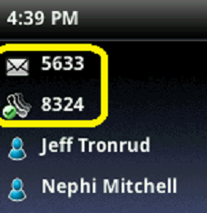

Side Note: What is a Shared Call Appearance?
Shared Call Appearances (SCAs) allow you to have several phone devices answering the same phone number. They also get the calls for their own number. For example, you might have multiple phones sharing a same main phone number that all ring at once. Or you might have an admin assistant fielding an exec’s phone extension in addition to the assistant’s own phone extension.

Heads Up:

If your phone logo has a red circle with an X in it as a badge on the phone icon then you don't have a functioning connection to Veracity Networks. Please call our support team for help with that. 801-437-6566 or 800-370-1104 or csgroup@veracitynetworks.com.

The blue head & shoulder icons indicate that they are Busy Lamp Fields which is another odd technical term. Busy Lamp Fields (BLFs) are a platinum license calling feature which enable people to monitor the phone status of other people in their group. They also function as speed dials. BLFs are limited to the number of line key buttons on the phone minus one button for the user's main line. | 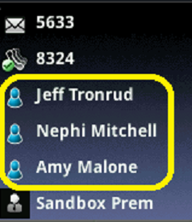

When a BLF co-worker is on a call, the red light on their line key button will turn on. And the blue icon will have a red circle with a bar through it. That indicates that they are on a call. | 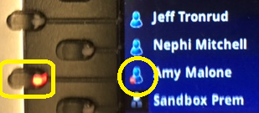

There are two more icons that you might need to know. The first one that looks like a phone's ghost signifies that this person's phone is ringing. The icon with a P in it indicates that this person has a call parked against their extension.

The grey head & shoulders icons indicate a speed dial. Just click the button to the right or left of a speed dial and that person will immediately be called without your having to key in a phone number. The creation of speed dials is covered further down. | 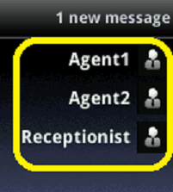

he lines view has "soft keys" under the screen and above the keypad. They vary depending on the version of your phone's firmware and the level of your license. Platinum licenses have a lot more features than premium licenses. | 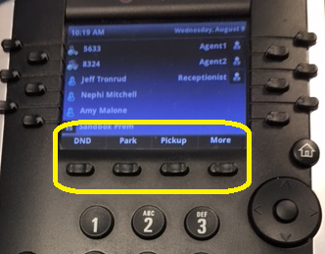

The home button is used to navigate between the three screens of a VVX400. Below that is the navigation wheel. Press the perimeter of that wheel to go up, down, left & right. Press the button in the center of the wheel to make a selection. | 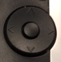

The other buttons are in the lower left & right corners. They are encircled in yellow in this picture. We'll cover each of them separately. | 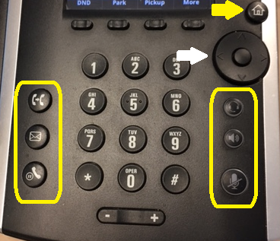

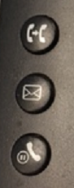 | The top left button has an image of a phone handset pointing at another handset. That is the transfer button. Push it once to initiate a transfer and it will automatically put your first caller on hold. Put in the destination number or extension then use the Send soft key to make the call.  If it's a blind transfer then click the button a second time to complete the transfer. For a warm transfer, wait for the destination to answer and click the button a 2nd time after you've consulted with the destination party.  Below that is a button with a picture of an envelope. That is for calling your voicemail. And the bottom left button is for putting people on hold and for taking them off hold.

The top right button has a headset graphic. It is for initiating a call via a headset. It also works to end a headset call. It lights up green when active. Below that is the speaker phone button that can be used to send and receive calls. It also lights up green when active.
The bottom right button has a graphic of a microphone with a bar through it. It lights up red when it is active. It's the mute button.

The volume bar is below the numeric keypad. Push the minus sign to lower the volume and the plus sign to increase the volume. If you're on a call then the volume of the call will change. If you're not on a call then it will change the ringer's volume. However, it will reset to its default volume when you hang up. | 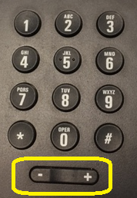

Speed Dials & Line Keys

Every unused line key is available for a speed dial so you can have up to 11 of them on a VVX400/410. The "line keys" are encircled in yellow in this screen shot. (The red circle is around the "soft keys.") Press and hold down on any empty line key and it will go into Add Contact mode after about 2 or 3 seconds. | 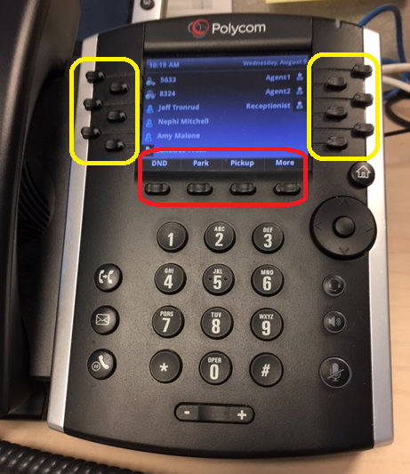

Use your keypad to put in a first name. Use the navigation wheel to put in the “Contact” which is the 10-digit phone number of the speed dial or an internal extension can be used. Ordinarily, you would need to put in a Favorite Index number to identify which line key is getting the speed dial. But this route will put in that number for you. | 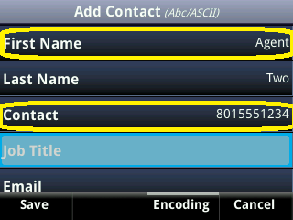

You can navigate down to see the Favorites Index number. All of the other fields are optional and typically ignored. However, many people also like to use the Ring Type option to give certain callers a special ring for easy identification. Press Save in the lower left corner when finished. | 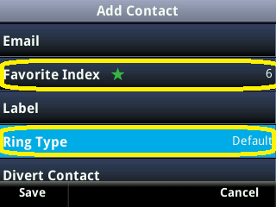

Contact Directories

You get to the contact directory and the call logs by clicking the home button then using the navigation wheel to go to the Directories screen. | 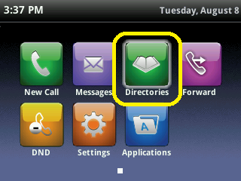
You can key in 1 to go to the Contact Directory or 2 to go into your Recent Calls which are your call logs. Either route gives you the opportunity to create a Favorites speed dial.  You can also use the navigation wheel to make a selection. And lastly, the Select soft key in the lower right corner can be used.  Let's start with option 1 to view the Contact Directory. | 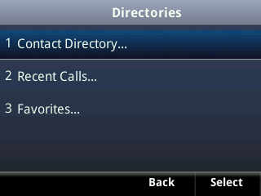

Click the Add soft key to add a new contact and/or speed dial. | 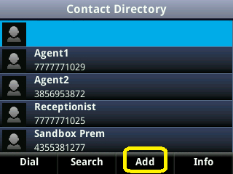

Use your keypad to put in a first name. Use the navigation wheel to put in the Contact which is the 10-digit phone number of the contact dial or their internal extension can be used.

If you want this contact to have a speed dial then use the navigation wheel to scroll down to the Favorite Index. You will need to put in the number of the line key. That isn't the phone number. Each line key has its own number from 1 to 11 which is the number of available line keys in addition to your main line.
Press the Save soft key and you're done. No reboot is needed.

Here is another way to create a speed dial or to edit an already existing contact. Begin by navigating to the Directories section.

Press 1 to get into the Contact Directory.

Use the navigation wheel to scroll down to your established contact. Then use the Info soft key in the lower right corner. | 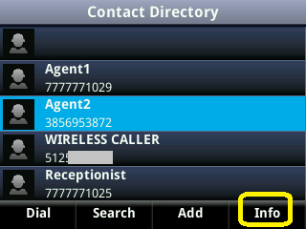

Now press the Edit soft key. | 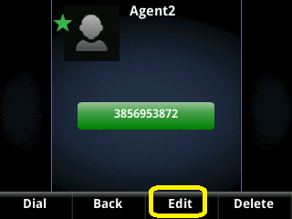

If you want this contact to have a speed dial then use the navigation wheel to scroll down to the Favorite Index. You will need to put in the number of the line key. That isn't the phone number. Each line key has its own number from 1 to 11 which is the number of available line keys in addition to your main line.
Press the Save soft key and you're done. No reboot is needed.

Recent Calls (Call Logs)

This section shows you how to view your call logs and then how to make a call log record into a Favorites speed dial.
You get to the call logs by clicking the home button then using the navigation wheel to go to the Directories screen. Use the button in the center of the navigation wheel to select that option.

Dial 2 to get into Recent Calls. You could also use the navigation wheel or the Select soft key to get in there.

The recent call list includes the caller's name (if recognized) and their phone number and the date. You can use the Info soft key to get more details. You can also use the Type soft key to limit the results to All Calls, Missed Calls, Received Calls & Placed Calls.  If there is a green circle with a downward arrow then it was an inbound call. A blue circle with an up & out arrow is an outbound call. | 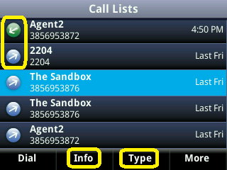

Missed calls are identified by a red circle with an X in it.  Use the Type soft key if you want to filter the call logs. | 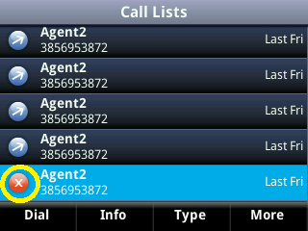

The call list defaults to all calls but you can use the navigation wheel and the Select soft key to limit the results to missed calls, received calls or placed calls.  If you have multiple lines then you will have an option to limit the results to a specific extension. You will need to use the navigation wheel to scroll down to see any such additional lines. | 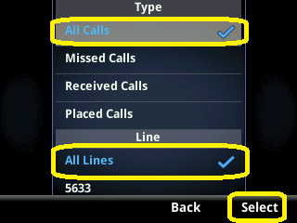

You can use the navigation wheel to select a specific call then use the Info soft key to see additional details as covered next.

If you use the Info soft key on a caller that is one of your Favorite speed dials then it will look like this. You can use the Edit soft key to alter the name if needed. And there is a Dial soft key for easy one press dialing.  The green star indicates that this caller is one of your Favorites. | 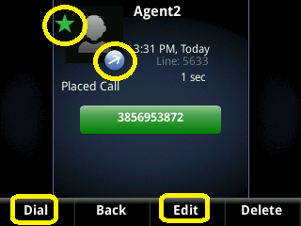

If the caller is not in your Contacts Directory then the Info soft key will bring up a screen like this. You can Edit or Dial the caller with the Edit/Dial soft key. The Save soft key makes it easy to add the caller to your Contacts Directory. Be sure to assign a Favorites Index number to specify an available line key if you want this caller to be a speed dial. | 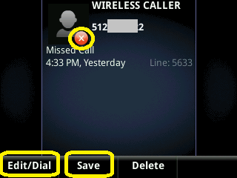

Settings Including Ring Tones

This section covers some additional settings such as customizing your ring tone. You get to these additional settings by clicking the house button then using the navigation wheel to go to the Settings screen. Use the button in the center of the navigation wheel to select that option. | 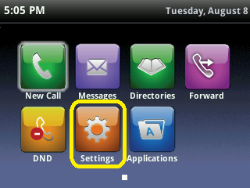

Most of what you might want to check is covered under option 1 Basic. The #2 Advanced section requires an admin password and covers very technical options that would only interest your phone system administrator. So let's take a look at option 1 Basic. | 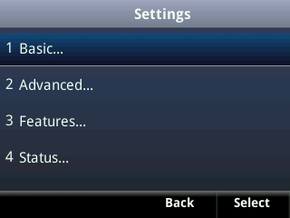

Tip: You don't need to use the navigation wheel and the Select soft key to make a choice. Just press 1 on your keypad to choose the Basic option or press 2 to go into Advanced and so on.

This is where you can choose your ring type at option 4. | 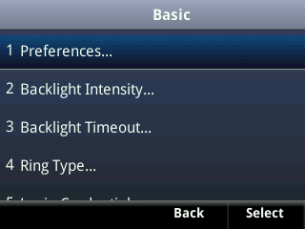

If you have multiple lines on your phone then you can select a separate ring type for each extension so that you can tell which line is ringing. If you only have one line on your phone then you won't see this screen. | 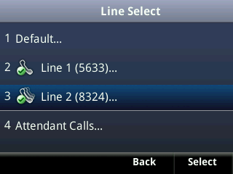

There are 15 different ringing options including Silent Ring and Ring Splash.
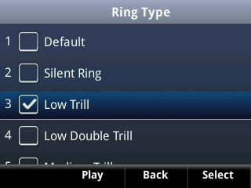 | 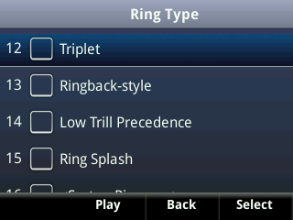

DND Do Not Disturb

Enabling Do Not Disturb (DND) will send all of your calls directly to your voicemail if you are setup with a voice mailbox. There are several ways to enable DND but we'll just cover the two most convenient routes. One way is to use the Home Key and the Navigation Wheel to select it from the home view. | 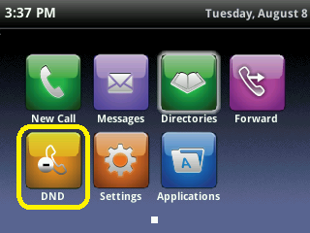

Another easy way is to use the DND soft key if you have that on your phone. It will toggle on/off each time that you press it. You might need to use the More soft key to see that option.  Note: Your soft key options will vary based upon the version of your phone's firmware as well as what your Veracity license includes. They also vary based upon how your phone system administrator has chosen to configure some things. | 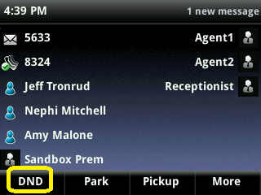

If you have multiple lines on your phone then you will need to choose which one gets the DND or you can choose the Set All soft key to do this to all of them at once. | 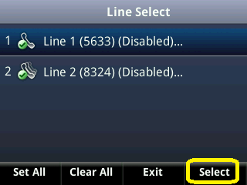

You will need to use the Enable/ Disable soft key to toggle DND on/off. | 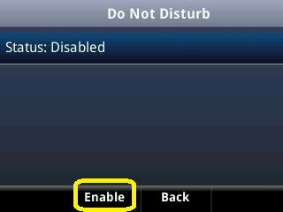

You can easily tell if DND is enabled by looking at the line's icon. If it has a red circle with a -bar in it then you are in Do Not Disturb mode. | 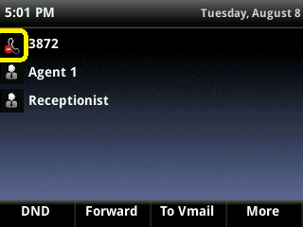

Similarly, you can see the red circle with a -bar- on the home screen. This also indicates that the line is in DND mode. | 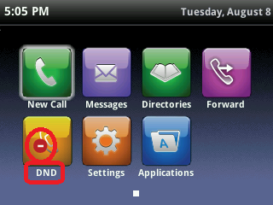

Call Forwarding Options

You can setup your phone to automatically forward your calls to another phone such as your cell phone or a co-worker's extension. There are several ways to enable this but we'll just cover the two easiest methods.  One way is to use the home button to go to the home screen then use the navigation wheel to put the phone's focus on the Forward option. Click the button in the middle of the navigation wheel to get into your three forwarding options. | 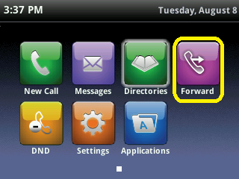

The other main way to enable/ disable call forwarding is to use the Forward soft key if you have one. You might need to use the More soft key to see that option.  Your soft key options may vary based upon the version of your phone's firmware as well as what your Veracity license includes. They also vary based upon how your phone system administrator has chosen to configure some things. | 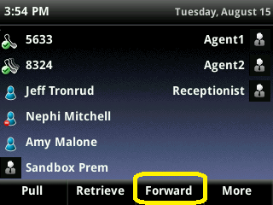

The three forwarding options are (1) Call Forwarding Always (CFA), (2) Call Forwarding No Answer (CFNA) and (3) Call Forwarding Busy (CFB). The first option CFA will forward every call no matter what. The 2nd option CFNA only forwards the call if you don't answer within a certain amount of rings. You get to choose how many rings. And the last option forwards your calls only if you're already busy talking on that phone. Key in a 1, 2 or 3 to make your selection. | 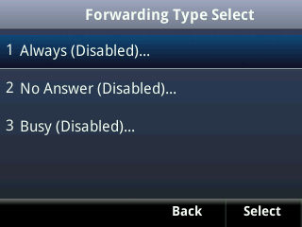

Each of these options will need you to specify the full 10-digit destination number or a Veracity phone extension. Then use the Enable soft key to turn on the forwarding. | 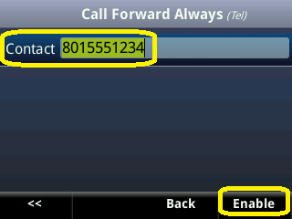

CFNA No Answer also needs you to specify the number of rings before the call will forward to your co-worker or wherever you want these calls to go. | 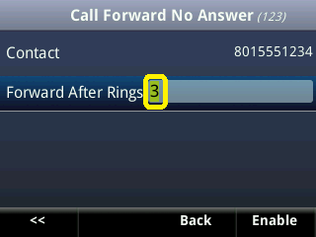

Enabling CFA will change the phone icon to a handset with a green arrow pointing out of it. The other call forwarding options do not change the icon. | 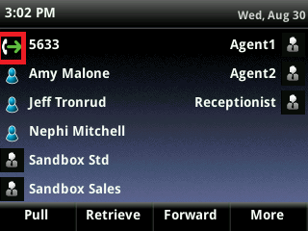

<end of document>

