Polycom VVX300/310 Phone User Manual

Let’s take a tour of the Polycom VVX300/310 phone. We’re going to cover the following topics: | 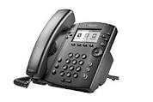
Screen Views & Call Handling
Soft Keys, Line Keys & Buttons
Contact Directories, Call Logs & Speed Dials
Settings Including Ring Tone Options
DND & Call Forwarding

Screen Views & Call Handling
Quick Links: Making Calls – Call Holds – Conference Calls – Blind Transfers – Warm Transfers – Shared Call Appearances – BLFs
There are 3 types of views on a VVX300/310 phone. They have a Home View, Lines View & Call View. You use the house button to navigate between them.
We'll start with the Home View shown here. The options are pretty self explanatory except that the call history is buried in the Directories section. Most of the buttons on the home view have their own section so let's move on to the call view.
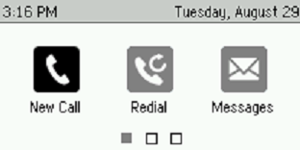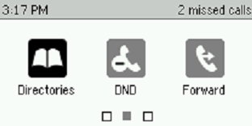
Quick Links: Messages – Directories – DND Do Not Disturb – Call Forwarding – Settings

Call View & Call Handling
The call view looks like this screen shot when you receive a call. You can press the Answer button at the bottom but it's easier to just pickup the handset. You can also use the speaker phone button or the headset button if you are setup with a headset for your calls. | 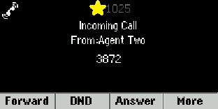

This phone has 2 lines which are extensions 1025 & 3873. The first thing this screenshot shows is which line took the call. That is extension 1025 in this case. It then shows that the call was received from Agent 2 and it shows his phone number which is extension 3872 in this screenshot.
If you have multiple lines then you can tell which extension is receiving the call because the button to the left of that extension will light up green. Just press on that button to answer the call. It will default to the speaker phone unless you've already lifted the handset or activated the headset button. If it answers by speaker phone then you can switch to your handset simply by picking it up. | 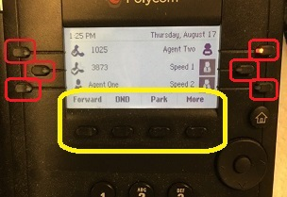

If one of these non-handset options is active then that button will be lit up green. If you press a lit button then the call will automatically go on hold and the green light will turn off. Press the button again to resume the call on the headset or speaker phone. The top button is the headset button and the middle button is the speaker phone.

There are various ways that you can initiate a call. You could go to the home view and choose the New Call option but that is the long route. It's much easier to simply start putting the number in the keypad. The << soft key to the left of the Dial soft key is how you delete a typo. Press the Dial soft key at the bottom after you've finished dialing. | 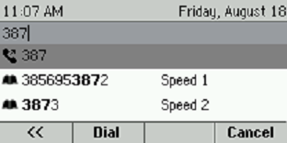

You can also use the speaker phone button on the right or the headset button if you're setup for that. The speaker phone button is the one in the middle this photo that looks like a speaker. Above that button is the headset button. If one of those options is active then the button will be lit up green.

This is how the Call View looks when there is a live phone call. This phone has 2 lines which are extensions 1025 & 3873. The first thing this screenshot shows is which line took the call. That is extension 3873 in this case. It then shows that the call was received from Agent 2 and it shows his phone number which is extension 3872 in this screenshot. Lastly, it shows that the call was 0 minutes and 10 seconds into the phone call. | 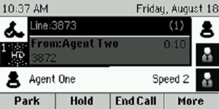

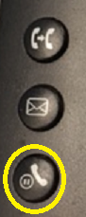 | There are several ways that you can put this call on hold to do things like setup a conference call or make a transfer. There is a Hold soft key button at the bottom of the screen. You also have a hold button on the phone as highlighted in this screen shot. If you press More and choose to transfer then the call automatically goes on hold. And if you are on the speaker phone or a headset and you press that lit button on the phone then that won't end the call. That will put the call on hold. Press the Hold button again to take the call off hold.

This is what it looks like if a call is on hold. You can take the call off hold by using the Resume soft key. You can also use the button described above as well as the speaker phone button or the headset button if applicable. | 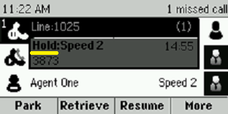
The soft key options at the bottom vary by license type and firmware version on the phone. In this example, we've got Park, Retrieve, Resume & More with more options if you choose that last one.
A Call Park is where you can park a call against any valid extension in your organization including possibly your own. Then you can go to a different phone or a co-worker can use the Retrieve option to grab that call on the other phone.
There are several ways to get two calls going at once. The main way is to put the first call on hold then dial the 2nd person. You can then initiate a transfer or conference call. The Join soft key also causes a 3-way conference call.
This is a screen shot where the phone has two calls going. Extension 1025 is talking to Agent 2 while extension 3873 (Speed Dial #2) is on hold. Either extension could have two calls going on the same extension but one would need to be on hold | 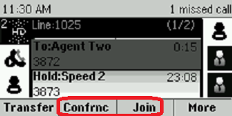
unless you've setup a conference call via the Confrnc or Join soft key. Note: You may need to use the More soft key to see these options.
While on a call, if you use the Transfer soft key then you will get this screen. You can use a soft key to switch to the Lines view or you can "Blind Transfer" which gives you a 2nd screen to put in a number and then you would click the Send soft key. | 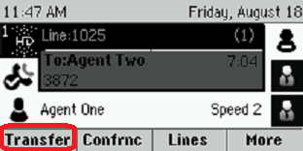

A blind transfer is where you don't talk to the destination before handing off the first caller. If you switch to Lines view then you can use a speed dial if you've got any speed dials setup on your phone.
This is the blind transfer screen. Key in a phone number or extension then use the Send soft key to pass along the call. | 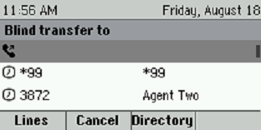
This is the consultative “warm” transfer window. Your original call goes on hold automatically. Type in the destination phone number and click the Send soft key. Talk to the destination then click the Transfer soft key to send the 1st caller to the destination caller. If they don't want the transfer then click the Cancel soft key and take the original caller off hold. | 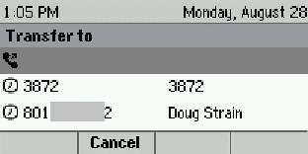

If you press and hold down the Transfer soft key for a few seconds then you will get this window. You can use the navigation wheel to switch to the other type of transfer this way. | 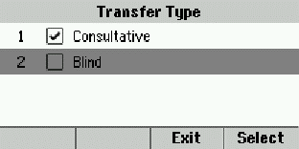
You can use the Confrnc soft key to initiate a conference call. You might need to use the More soft key to see the Confrnc soft key. |  | 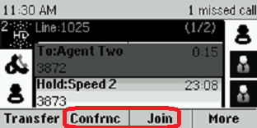

While on a conference call, you will have a Split soft key. You might need to use the More soft key to get to that Split option. This will split the call into two separate calls. | 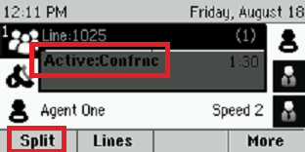

Use the End Call soft key or simply hang up to leave the conference call. The other two callers will continue to be on a call with each other. | 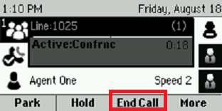

Lines View
This is the lines view. We'll break it into pieces starting with your main line and any other shared lines that you might have on your phone. | 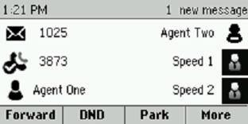

Let's start in the top left corner where the main line is situated. In this screen shot, that is extension 1025 while the checkmark telephone logo just below 1025 at extension 3873 is a shared line known in the telephony industry as a "Shared Call Appearance." | 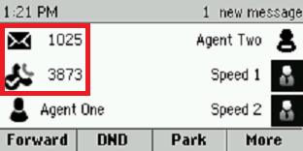

Ordinarily, 1025 would also have a checkmark phone logo except that extension has an unheard voicemail message so an envelope icon has replaced the green check mark.
Side Note: What is a Shared Call Appearance?

Shared Call Appearances (SCAs) allow you to have several phone devices answering the same phone number. They also get the calls for their own number. For example, you might have multiple phones sharing a same main phone number that all ring at once. Or you might have an admin assistant fielding an exec’s phone extension in addition to the assistant’s own phone extension.

The black head & shoulder icons indicate that they are Busy Lamp Fields which is another odd technical term. Busy Lamp Fields (BLFs) are a platinum license calling feature which enable people to monitor the phone status of other people in their group. They also function as speed dials. | 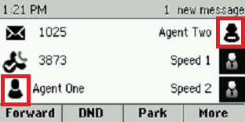
The highlighted icon on the right with a bar across the chest indicates that this BLF user is on a call.
The grey head & shoulders icons indicate a speed dial. Just click the button to the right or left of a speed dial and that person will immediately be called without your having to key in a phone number. The creation of speed dials is covered in its own page. | 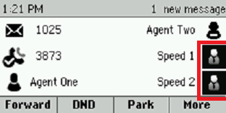
Soft Keys, Line Keys & Buttons

The lines view has "soft keys" under the screen and above the keypad. They're encircled in yellow in this screenshot. They vary depending on the version of your phone's firmware and the level of your license. Platinum licenses have a lot more features than premium licenses.

The buttons encircled in red are known as line keys. The very first one in the top left corner is always your main extension. The rest of the line keys are optional. If you have any shared call appearances then they would follow your main extension.
After that, you might have some Busy Lamp Fields where you could see if specific co-workers are busy on the phone. When they're talking on their phone, the line key will have a red light showing. If their phone is ringing then it will start blinking with a green light.
Lastly and most commonly, these line keys can be setup as speed dials which will be explained further down.
 | The home button is used to navigate between the three screens of a VVX300/310.
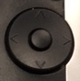 | Below the home button is the navigation wheel. Press the perimeter of that wheel to go up, down, left & right. Press the button in the center of the wheel to make a selection.

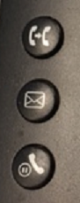 | The remaining buttons are in the lower left & right corners.  The top left button has an image of a phone handset pointing at another handset. That is the transfer button. Push it once to initiate a transfer and it will automatically put your first caller on hold. Put in the destination number or extension then use the Send soft key to make the call.
If it's a blind transfer then click the button a second time to complete the transfer. For a warm transfer, wait for the destination to answer and click the button a 2nd time after you've consulted with the destination party.
Below that is a button with a picture of an envelope. That is for calling your voicemail. And the bottom left button is for putting people on hold and for taking them off hold.
The top right button has a headset graphic. It is for initiating a call via a headset. It also works to end a headset call. It lights up green when active. Below that is the speaker phone button that can be used to send and receive calls. It also lights up green when active.
The bottom right button has a graphic of a microphone with a bar through it. It lights up red when it is active. It's the mute button.

The volume bar is below the numeric keypad. Push the minus sign to lower the volume and the plus sign to increase the volume. If you're on a call then the volume of the call will change. If you're not on a call then it will change the ringer's volume. However, it will reset to its default volume when you hang up. | 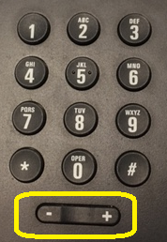

Contact Directories
You get to the contact directory and the call logs by clicking the home button then using the navigation wheel to go to the Directories screen. | 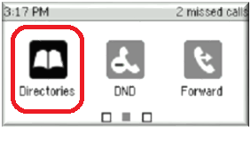

Press the edge of the navigation wheel to go left, right, up & down. Press the button in the center of the wheel to make a selection. So in this case, you would press the right edge of the navigation wheel three times to put the phone's focus over the Directories section. Then click the center button of the wheel to open the Directories.
You can key in 1 to go to the Contact Directory or 2 to go into your Recent Calls which are your call logs. Either route gives you the opportunity to create a Favorites speed dial.  You can also use the navigation wheel to make a selection. And lastly, the Select soft key in the lower right corner can be used. |  | 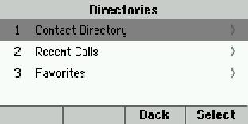
Let's start with option 1 to view the Contact Directory. Click the Add soft key to add a new contact and/or speed dial. | 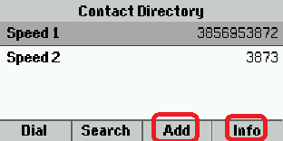

Use your keypad to put in a first name. Use the navigation wheel to put in the Contact which is the 10-digit phone number of the contact dial or their internal extension can be used. | 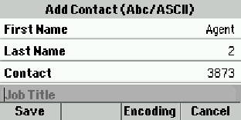

If you want this contact to have a speed dial then use the navigation wheel to scroll down to the Favorite Index. You will need to put in the number of the line key. That isn't the phone number. Each line key has its own number from 1 to 11 which is the number of available line keys in addition to your main line.  Press the Save soft key and you're done. No reboot is needed. | 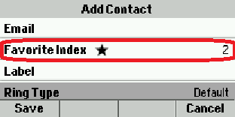

Here is another way to create a speed dial or to edit an already existing contact. Begin by navigating to the Directories section. | 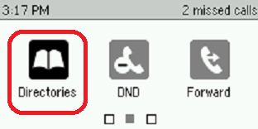

Press 1 to get into the Contact Directory.

Use the navigation wheel to scroll down to your established contact. Then use the Info soft key in the lower right corner.

Now press the Edit soft key. | 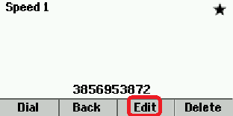

Use the navigation wheel to scroll down to Favorite Index and/or Ring Type. | 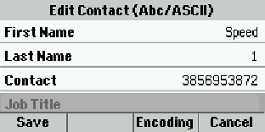

If you want this contact to have a speed dial then use the navigation wheel to scroll down to the Favorite Index. You will need to put in the number of the line key. That isn't the phone number. Each line key has its own number from 1 to 5 which is the number of available line keys in addition to your main line. | 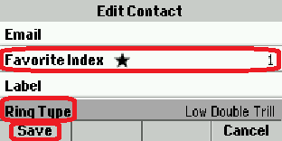
You can give your contacts distinctive ringing patterns to make them easily recognizable.
Press the Save soft key and you're done. No reboot is needed.
Call Logs
This section shows you how to view your call logs and then how to make a call log record into a Favorites speed dial.
You get to the call logs by clicking the home button then using the navigation wheel to go to the Directories screen. Use the button in the center of the navigation wheel to select that option.

Dial 2 to get into Recent Calls. You could also use the navigation wheel or the Select soft key to get in there. | 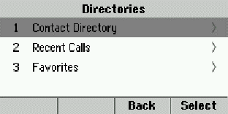

The recent call list includes the caller's name (if recognized) and their phone number and the date. You can use the Info soft key to get more details.  Each call has a circular icon to the left of it. A down arrow is incoming and an up arrow is an outbound call. The X version is a missed call. | 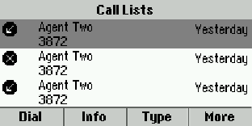

You can use the Type soft key to limit the results to All Calls, Missed Calls, Received Calls & Placed Calls. The call list defaults to all calls but you can use the navigation wheel and the Select soft key to limit the results to missed calls, received calls or placed calls. | 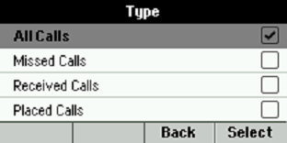

If you have multiple lines then you will have an option to limit the results to a specific extension. You will need to use the navigation wheel to scroll down to see any such additional lines.
You can use the navigation wheel to select a specific call then use the Info soft key to see additional details as covered next.

If you use the Info soft key on a caller that is one of your Favorite speed dials then it will look like this. You can use the Edit soft key to alter the name if needed. And there is a Dial soft key for easy one press dialing. The star indicates that this caller is one of your Favorites. | 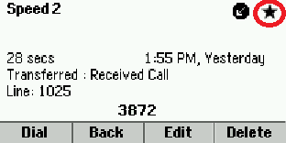
If the caller is not in your Contacts Directory then the Info soft key will bring up a screen like this. You can Edit or Dial the caller with the Edit/Dial soft key. The Save soft key makes it easy to add the caller to your Contacts Directory. Be sure to assign a Favorites Index number to specify an available line key if you want this caller to be a speed dial. | 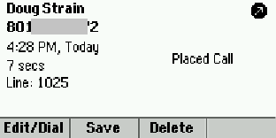

Creating Speed Dials
Every unused line key is available for a speed dial so you can have up to 5 of them on a VVX300/310. The "line keys" are encircled in red in this screen shot. (The yellow circle is around the "soft keys.") Press and hold down on any empty line key and it will go into Add Contact mode after about 2 or 3 seconds.
Use your keypad to put in a first name. Use the navigation wheel to put in the Contact which is the 10-digit phone number of the speed dial or an internal extension can be used. Ordinarily, you would need to put in a Favorites number to identify which line key is getting the speed dial. But this route will put in that number for you. | 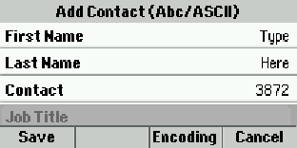
You can navigate down to see the Favorites Index number. All of the other fields are optional and typically ignored. However, many people also like to use the Ring Type option to give certain callers a special ring for easy identification. Press Save in the lower left corner when finished. | 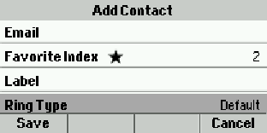

Settings
This page covers some additional settings such as customizing your ring tone. You get to these additional settings by clicking the home button then using the navigation wheel to go to the Settings screen. Use the button in the center of the navigation wheel to select that option. | 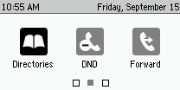  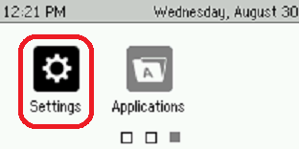

Most of what you might want to check is covered under option 1 Basic. The #2 Advanced section requires an admin password and covers very technical options that would only interest your phone system administrator. So let's take a look at option 1 Basic. | 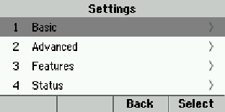

Note: You don't need to use the navigation wheel and the Select soft key to make a choice. Just press 1 on your keypad to choose the Basic option or press 2 to go into Advanced and so on.
This is where you can choose your ring type at option 5. | 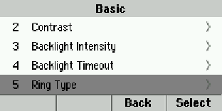

If you have multiple lines on your phone then you can select a separate ring type for each extension so that you can tell which line is ringing. If you only have one line on your phone then you won't see this screen. | 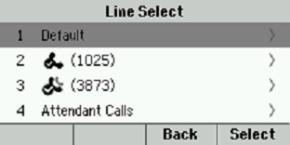

There are 15 different ringing options including Silent Ring and Ring Splash.  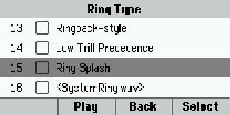 | 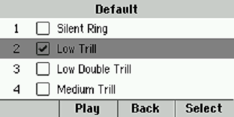

DND – Do Not Disturb
Enabling Do Not Disturb (DND) will send all of your calls directly to your voicemail if you are setup with a voice mailbox. There are several ways to enable DND but we'll just cover the two most convenient routes. One way is to use the Home Key and the Navigation Wheel to select it from the home view. | 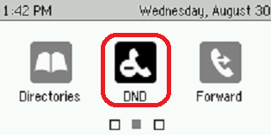

Another easy way is to use the DND soft key if you have that on your phone. It will toggle on/off each time that you press it. You might need to use the More soft key to see that option. | 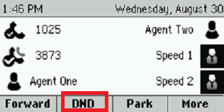

Note: Your soft key options will vary based upon the version of your phone's firmware as well as what your Veracity license includes. They also vary based upon how your phone system administrator has chosen to configure some things.
If you have multiple lines on your phone then you will need to choose which one gets the DND or you can choose the Set All soft key to do this to all of them at once. | 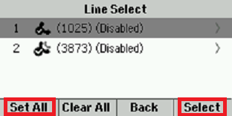

You will need to use the Enable/Disable soft key to toggle DND on/off. | 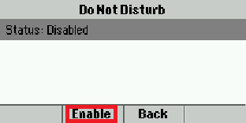

You can easily tell if DND is enabled by looking at the line's icon. If it has a bar instead of a checkmark in it then you are in Do Not Disturb mode. This screenshot indicated that the 3873 extension is in DND mode. | 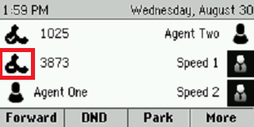

Similarly, you can see a bar on the home screen. This also indicates that the line is in DND mode. | 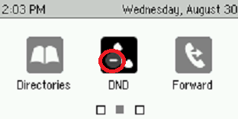
Call Forwarding Options
You can setup your phone to automatically forward your calls to another phone such as your cell phone or a co-worker's extension. There are several ways to enable this but we'll just cover the two easiest methods. | 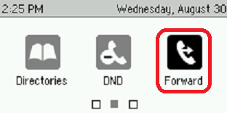
One way is to use the home button to go to the home screen then use the navigation wheel to put the phone's focus on the Forward option. Click the button in the middle of the navigation wheel to get into your three forwarding options.
The other main way to enable/disable call forwarding is to use the Forward soft key if you have one. You might need to use the More soft key to see that option. | 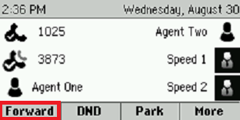

Your soft key options may vary based upon the version of your phone's firmware as well as what your Veracity license includes. They also vary based upon how your phone system administrator has chosen to configure some things.
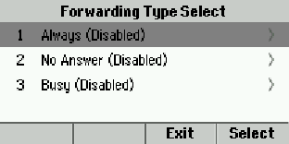
The three forwarding options are (1) Call Forwarding Always (CFA), (2) Call Forwarding No Answer (CFNA) and (3) Call Forwarding Busy (CFB). The first option CFA will forward every call no matter what. The 2nd option CFNA only forwards the call if you don't answer within a certain amount of rings. You get to choose how many rings. And the last option forwards your calls only if you're already busy talking on that phone. Key in a 1, 2 or 3 to make your selection.
Each of these options will need you to specify the full 10-digit destination number or a Veracity phone extension. Then use the Enable soft key to turn on the forwarding. | 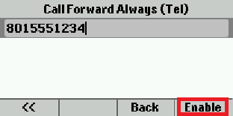
CFNA No Answer also needs you to specify the number of rings before the call will forward to your co-worker or wherever you want these calls to go. In this example, it is set to forward to 8015551234 after 5 rings. | 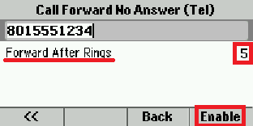
Enabling CFA will change the phone icon to be a hung up handset with a broken arrow on top of it. The other call forwarding options do not change the icon. | 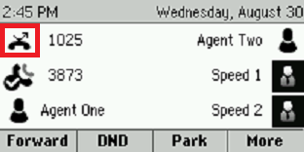
<end of document>

